CHME NEWSLETTER JUNE 2017 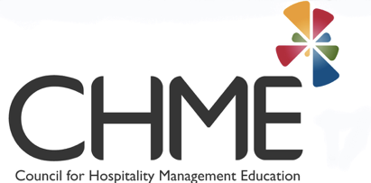

CHME Annual Research Conference, Aalborg, Denmark May 16 - 19th 2017
In its first foray outside of the UK, CHME held its Annual Research Conference in Aalborg, Denmark, hosted by Anders Johannes Justenlund, UCN, Aalborg. The conference attracted visitors from across the globe, and notably from the local business community. In addition to the academic programme, and also industry focussed sessions, RedGlobal ran workshops leading to a group of 25 students receiving their Revenue Management certification. Fellowships were awarded and individual awards made. Read more…..
SHARE sponsored awards were also conferred for:
Best teaching innovation, awarded to Mr. Ken Woodward and Dr Ioannis S. Pantelidis for their Menu Museum ( menumuseum.eu ). Read more……
Most impactful research, awarded to Maureen Brookes, Alexandros Paraskevas & Angela Roper for the Combat Trafficking in Human Beings (THB) Project. Read more….
CHME Research Conference 2018 is already under preparation, to be hosted by Bournemouth University, on the South coast of the UK. Read more…..
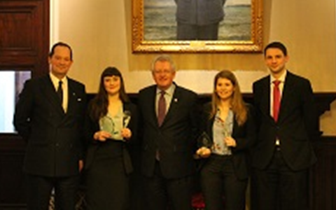
CHME Young Guns
Young Guns is a competition for final year students who have been on a placement year. We were pleased to receive nominations from many institutions this year. In March 2017, CHME welcomed the 8 finalists to the Young Guns lunch at the RAF Club, Piccadilly London, as guests of Miles Pooley, the Chief Executive and Club Secretary of the Club.
The standard of the finalists who represented 6 CHME University members was extremely high and made the judging very challenging. Leonora Brebner (on the right) from Robert Gordon University Aberdeen and Rosie Maguire (on the left) from Derby University were presented with their awards following challenging interviews during a wonderful lunch hosted by Miles Pooley at the Royal Air Force Club, London. We congratulate two worthy winners.
Rosie also attended the CHME conference in Aalborg, her first experience of attending and presenting at a conference. She reflects on her experiences…..Read more……

EMCup (European Mis en Place Cup)
This was the 9th ‘edition’ of this competition, held in Maastrict, in the Netherlands, and attracting entries from 32 European Hotel Management Schools. This year teams of students were sked to address the theme ‘Catch me if you can - stay in love’ and was about graduate retention in the hospitality industry……Read more…….

HEA-funded study into ‘Challenges in hospitality management education’
This study, conducted by CHME for the HEA has now been published in the peer-reviewed literature:
Lugosi P & Jameson S (2017) Challenges in hospitality management education: Perspectives from the United Kingdom’. J Hospitality and Tourism Management 31, 163 - 172

